**ASSIGNMENT 2.2**

Problems:

**Task 3**: Create a file max-temp.txt in local FS.

Step 1: Create a file map-temp.txt using touch command in the local FS (since I’ve typed map-temp.txt).

Expected Output: [acadgild@localhost ~]$ touch map-temp.txt

Step 2: Then putting the 10-15 records in a file using gedit.

Expected Output: [acadgild@localhost ~]$ sudo gedit map-temp.txt

e.g- 10-01-1990, 10

10-02-1991, 20

And so on

Step 3: Then we move the file from Local Fs to Hdfs by using moveFromLocal command

Expected Output:

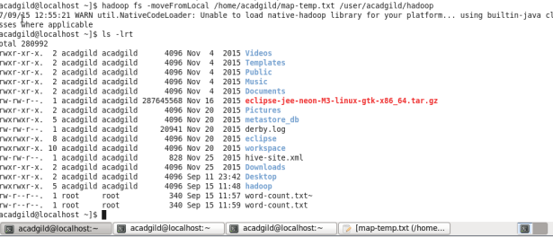

Step 4: Then we see whether the file map-temp.txt has moved under the directory of /user/acadgild/hadoop

Expected Output:

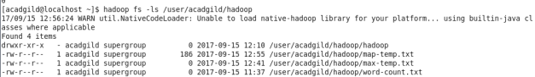

In the above solution of the screenshot you will see map.txt present in the directory of /user/acadgild/hadoop.

Step 5: Lastly we see the content of the map-temp.txt file in hdfs.

Expected Output:

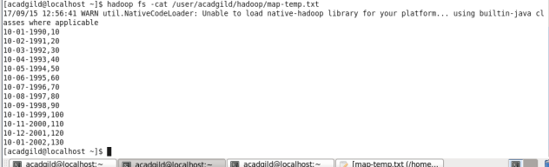

**Task 4**: Change the permission of the file /user/acadgild/hadoop/map-temp.txt, such that

only the owner and the group members have full control over the file.

Step 1: First to check whether the file map-temp.txt exist or not.

Command : hadoop fs -ls /user/acadgild/hadoop.

The above command -ls is to see the list of the directory.

Expected Output:

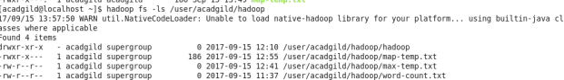

In map-temp.txt the permission is given as –rwxr-xr-x means –rwx- means the permission is read, write and execute for the owners/users and –xr- means the permission is to read and execute for groups and –x means the permission is to only execute for all others members not read and write.

Step 2: Now I’ve to change the permission of the file which is able to access only the owner/users and the groups.

Command: hadoop fs –chmod –r 770 /user/acadgild/hadoop/map-temp.txt

Output:

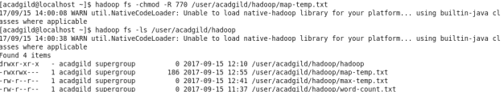

See, the permission changes i.e., –rwxrwx--- in map-temp.txt

7 -rwx –read, write and execute for owner or user i.e., they have full permission to access.

7 -rwx – read,write and execute for groups i.e., the group members have full permission

0 --- - no permission to others members.